

UNIVERSITI MALAYSIA TERENGGANU

FACULTY OF OCEAN ENGINEERING TECHNOLOGY & INFORMATICS

[CSM3114]

FRAMEWORK-BASED MOBILE APPLICATION DEVELOPMENT

**TITLE: HAULIER TRACKING APPLICATION**

GITHUB LINK:

PREPARED BY:

NUR ELYA FARHANA BINTI ZAINORDIN (S63723)

PREPARED FOR:

DR. MOHAMAD NOR BIN HASSAN HASSAN

[BACHELOR OF COMPUTER SCIENCE (MOBILE COMPUTING) WITH HONOURS]

SEMESTER I 2023/2024

Table of Contents

**1.0 Executive summary** 3

**2.0 Use Case** 4

Figure 2.1 Homepage 4

Figure 2.3 Offer a Ride page 4

**3.0 The common structure of tree widgets used when designing and developing the application (max 2pages)** 5

Figure 3.1 Homepage 5

Figure 3.3 Find a Ride 6

**4.0 Flutter widget and features adopted in the application(max 2 pages)** 7

**5.0 Sample of interface with the explanation(max 3 pages)** 8

**6.0 Conclusion** 9

**7.0 Reference** 10

## **1.0 Executive summary**

The Haulier Tracking App is a complete solution made to improve and streamline the transportation and logistics sector's productivity. This cutting-edge tool gives hauliers the ability to track and monitor in real-time, enabling them to streamline their processes and raise the standard of their services.

Fundamentally, the software improves route planning and logistics coordination by letting hauliers track the whereabouts and conditions of their fleet in real time. The software uses GPS technology to deliver precise and current information, facilitating prompt decision-making and cutting down on delays. In addition to helping haulers, this real-time tracking function improves customer happiness by offering precise arrival estimates and increased transparency.

With its extensive capabilities, which include route optimization, fuel usage monitoring, and vehicle maintenance scheduling, the Haulier Tracking App goes beyond basic location tracking. Hauliers can save operating expenses, optimize fuel efficiency, and guarantee fleet maintenance by utilizing these capabilities. Hauliers can easily access and understand crucial data thanks to the app's user-friendly layout, which helps them make better business decisions.

In the logistics sector, security and data integrity are critical, and the Haulier Tracking App takes sophisticated security precautions to meet these needs. The application utilizes encryption algorithms to protect confidential data, guaranteeing that only individuals with proper authorization can access vital information. This dedication to security raises the platform's credibility and makes it a dependable resource for haulage companies.

To sum up, the Haulier Tracking App is an advanced system that is completely changing the logistics and transportation industry. Through the integration of real-time tracking, route optimization, and comprehensive security measures, the app enables hauliers to optimize their operations, minimize expenses, and provide their customers with superior service. The Haulier Tracking App is at the vanguard of this industry's ongoing evolution, promoting efficiency and positive transformation in the haulage sector.

## **2.0 Use Case**

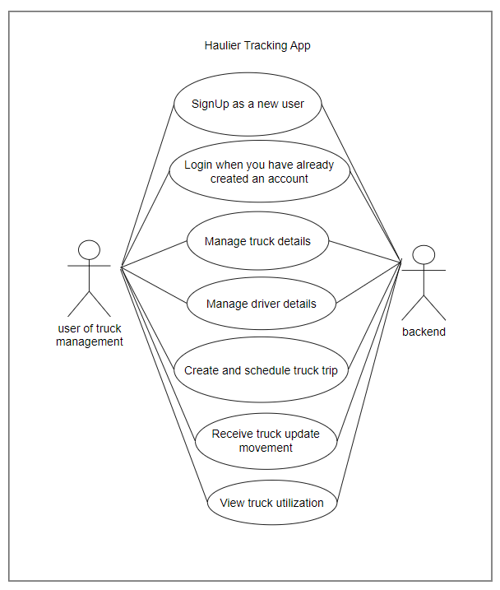

Figure 2.1 Haulier Track Use Case

## **3.0 The common structure of tree widgets used when designing and developing the application (max 2pages)**

## **4.0 Flutter widget and features adopted in the application(max 2 pages)**

## **5.0 Sample of interface with the explanation(max 3 pages)**

## **6.0 Conclusion**

Considering the initial obstacles that the logistics and transportation business experienced, the Haulier Tracking App shows up as a game-changing solution that gets past these obstacles and redefines industry norms. From the beginning, when delays and inefficient logistics were typical, the app ushered in a new era of more secure, real-time tracking, and optimized operations. By breaking with conventional methods, its deployment ushers in a new era where hauliers can precisely navigate their fleets, optimize routes for maximum efficiency, and guarantee the confidentiality and integrity of vital data. By filling in these gaps in the industry, the Haulier Tracking App transforms logistics and leads the industry into a new era of technical innovation and operational excellence.

## **7.0 Reference**

1. Marwiyah, M., Arti, P. P., & Hidayat, T. (2022, November 22). *An Analysis of Online Transportation Applications Between Gojek and Grab for Students*. International Journal of Science Education and Cultural Studies. https://doi.org/10.58291/ijsecs.v1i1.28
2. *Biessek (2019)-Flutter for Beginners*. (2019). https://epembelajaran.umt.edu.my/oceania/pluginfile.php/382830/mod_resource/content/1/Biessek%20%282019%29-Flutter%20for%20Beginners.pdf.
3. *Flutter documentation*. (n.d.). Flutter. https://docs.flutter.dev/